Level 4 -> Level 5

The goal of this level is to find out the human readable file in the **inhere** directory and get the password of next level.

So now, firstly we will check the files and folders of the current directory in which we are by using **ls** command. Simple **ls** command is used to list out all the files and folder of the directory in which the user is present. A directory named **inhere** is present in the current directory in which we are. We will jump into this directory using **cd** command.

Again, using ls command, we will check files and directories present in inhere directory. We found 10 different files and it will be difficult for us to check each file to find human readable file. So, we will use **file** command with an option **./\*** to get the type of file.

Here file named **-file07** is ASCII text i.e. human readable file.

We can read the content of this file by using **cat ./-file07** command.The file contains the password for level 5.

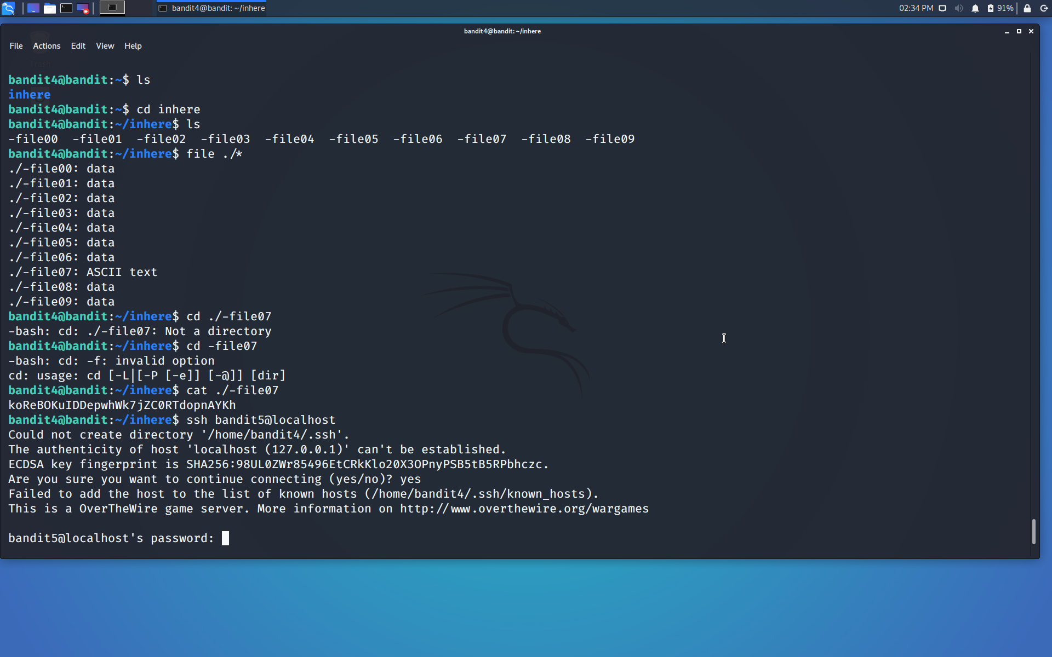

Use the command **ssh bandit5@localhost** to connect to the level 5.

Enter the password and hit enter.

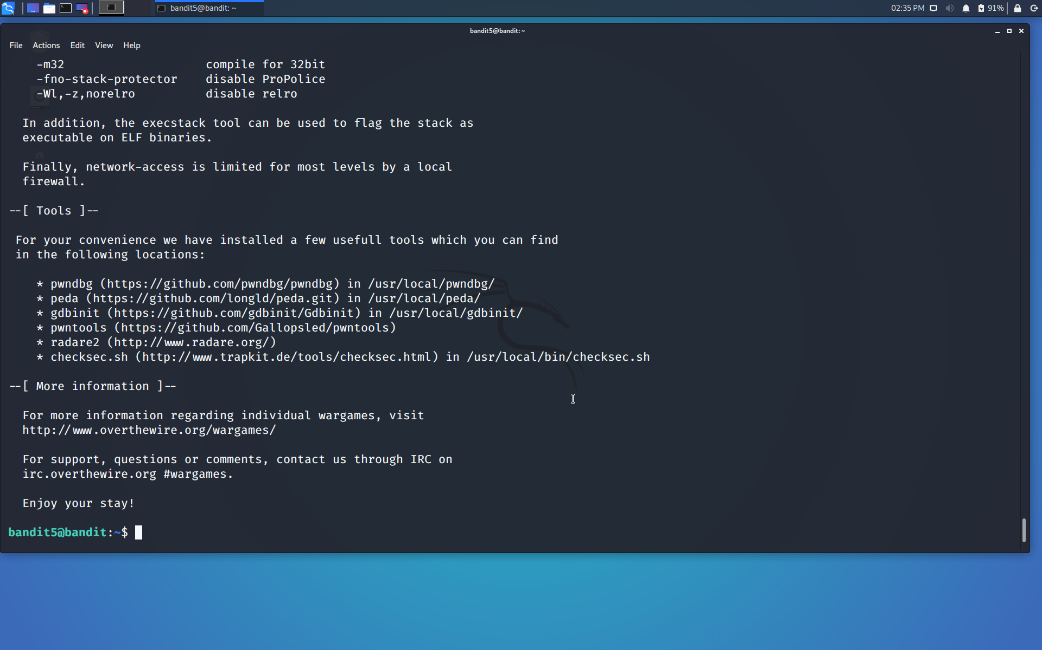

Successfully passed level 5.…